Hand Banner
This hand banner craft makes a good class or family project. Why not make the banner long enough to circle a room so it joins together in a unified circle? Each child can use a different quote and think about its meaning.
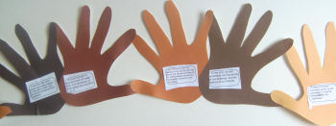
You will need:
A range of skin colored paper or card
Glue stick
Paper and pens for writing, or a print out of our Martin Luther King quotes (Google to find quotes from Martin Luther King, Jr.)
Instructions:
Cut out a number of handprints, making half left hands and half right hands. Either cut out and glue on one of our quotes to each hand or have children research and write on their own.
Take one left hand and one right hand and glue the ends of the index fingers and thumbs together. Make lots of pairs of hands in the same way.
Glue the pairs together by overlapping the little finger and the edge of the palm. Hang your banner.

Dove of Peace Craft
Martin Luther King's message was always one of peace. Try this pretty dove of peace craft as a reminder. This dove is also very pretty hanging from the Christmas Tree!
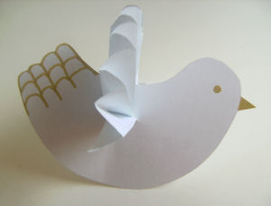
You will need:
White card
White paper
Thread
Glue
Gold pen
Dove template provide on separate page
Instructions:
Draw a dove shape on card or print our template. Cut out, and decorate the dove with gold pen.
Lay the paper flat in front of you. Fold over a piece about ½ inch wide. Turn the paper over and fold again. Keep going until all paper is folded.
Cut a slit in the center of the dove and slide the folded paper half way through. Fold the top edges of the folded paper up to join one another and glue together.
If you want to hang the dove punch a hole at the top of the wings and tie through a length of thread.

